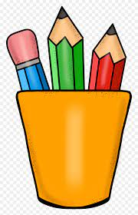

***First Grade Supply List***

Backpack

Lunchbox

Pencils

Pencil sharpener

Water bottle

Dry erase markers

Pair of scissors

Box of crayons

Pack of erasers

Headphones

One composition notebook

Glue sticks

Folders

***Classroom Supplies***

Box of tissues

Papertowels

Wipes

***Optional***

Box of Markers

Water Bottles